

**SAVEETHA SCHOOL OF ENGINEERING**

**SAVEETHA INSTITUTE OF MEDICAL AND TECHNICAL SCIENCES**

**CHENNAI-602105**

**TRAVEL BOOKING SYSTEM**

**A CAPSTONE PROJECT REPORT**

*Submitted in the partial fulfillment for the completion of the course*

**CSA4309-INTERNET PROGRAMMING FOR WEB SERVICES**

**IN**

**COMPUTER SCIENCE AND ENGINEERING**

**Submitted by**

**V.Ramayya (192210191)**

**Sandeep Reddy. S (192210010)**

**Dinesh Karthik. P (192210043)**

**Under the Supervision of**

**Dr. K. Jayasakthi Velmurugan**

**NOV 2024**

**DECLARATION**

We, V. **Ramayya, Sandeep Kumar Reddy. S, Dinesh Karthik. P,** students of **Bachelor of Engineering in the Department** of Computer Science and Engineering, Saveetha Institute of Medical and Technical Sciences, Saveetha School of Engineering, Chennai, hereby declare that the work presented in this Capstone Project Work entitled **Travel Booking System** is the outcome of our own bonafide work and is correct to the best of our knowledge and this work has been undertaken taking care of Engineering Ethics.

(V.Ramayya -192210191)

(Sandeep Reddy. S -192210010)

(Dinesh Karthik. P-192210043)

Date:12/11/2024

Place:chennai

**CERTIFICATE**

This is to certify that the project entitled **“Travel Booking System”** submitted by V. **Ramayya, Sandeep Kumar Reddy. S, Dinesh Karthik. P** has been carried out under my supervision. The project has been submitted as per the requirements in the current semester of B.E. Computer Science and Engineering.

Supervisor

Dr. K. Jayasakthi Velmurugan

**TABLE OF CONTENTS**

|  |  |  |
| --- | --- | --- |
| S.NO | TOPICS | PAGE NO. |
| 1 | Introduction | 5 |
| 2 | Objectives | 6 |
| 3 | Existing System & Drawbacks | 7 |
| 4 | Proposed System | 8 |
| 5 | Block Diagram | 9 |
| 6 | Techniques & Coding | 10 to 17 |
| 7 | Results | 17 & 19 |
| 8 | Conclusion & Future Enhancements | 20 |
| 9 | References | 21 |

**INTRODUCTION**

In today’s digital era, an intuitive and visually engaging website is essential for any travel booking system. A well-designed travel website not only attracts users but also provides a seamless experience in browsing destinations, comparing prices, and booking itineraries. This project focuses on designing a user-centered travel booking platform that integrates modern design principles with robust functionality to enhance usability, responsiveness, and accessibility. By prioritizing aesthetic appeal and ease of navigation, the platform ensures that users can easily interact with features like destination filters, trip packages, and secure payment options.

The proposed design incorporates advanced search and filtering options, personalized recommendations, and interactive elements such as maps, reviews, and real-time booking availability. User experience (UX) and user interface (UI) components are carefully crafted to provide a streamlined journey from initial search to final booking. Additionally, mobile optimization is emphasized to cater to on-the-go travelers, allowing them to book their trips seamlessly across devices. By employing responsive web design techniques, the platform ensures a consistent and intuitive experience on both desktop and mobile screens.

To ensure security and trustworthiness, the system integrates secure payment gateways and complies with industry standards for data protection. Visual hierarchy, call-to-action buttons, and feedback mechanisms are implemented strategically to guide users through the booking process smoothly. The result is a user-friendly, secure, and visually appealing travel booking website that meets the evolving needs of modern travelers, helping them book their dream vacations with confidence and ease.

**OBJECTIVES**

Our project involves creating an engaging and user-friendly website design for a travel booking system that serves as a comprehensive platform for users to explore, compare, and book travel accommodations and activities seamlessly. This website aims to offer a visually appealing interface that encourages users to delve into travel possibilities, with organized layouts for flights, hotels, car rentals, and excursions, all accessible from one place. With a focus on ease of navigation, the design will cater to both seasoned travelers and first-time users, offering intuitive search filters, stunning visuals, and clear information to make travel planning a breeze.

The core of this travel booking system lies in its intelligent design and responsiveness, catering to diverse device users by offering a consistent experience across desktops, tablets, and mobile devices. Enhanced search and sorting features will help users find options based on budget, location, dates, and preferences, all displayed in a streamlined, uncluttered manner. Visuals will be carefully chosen to evoke a sense of wanderlust, showcasing destination highlights, popular tourist spots, and user-generated content such as reviews and photos. Integrated customer support options, such as live chat or a help center, will ensure that users have quick access to assistance when needed, boosting trust and convenience.

Furthermore, the website will incorporate secure booking and payment options, assuring users of their data privacy and making transactions seamless. This project is designed to inspire confidence and excitement around travel, using a combination of practical tools and engaging content to assist users at every step of the booking process. In addition, the design will include personalized recommendations, based on past bookings or stated preferences, experience that transforms travel booking from a task into an enjoyable, immersive journey.

**EXISTING SYSTEM**

1. Global Distribution Systems (GDS):

Amadeus: A leading GDS that provides technology solutions to travel agents, airlines, and other travel businesses worldwide, offering flight, hotel, and car rental bookings.

Sabre: A GDS widely used by travel agencies and airlines for booking flights, hotels, and other travel services.

Travelport (Galileo, Worldspan, and Apollo): Offers integrated travel commerce solutions for travel agencies and travel service providers.

2. Online Travel Agencies (OTAs):

Booking.com: An online platform that allows users to search and book hotels, flights, rental cars, and other travel services.

Expedia: Offers a wide range of travel services, including flights, hotels, car rentals, and vacation packages.

TripAdvisor: Provides travel planning and booking services for hotels, restaurants, flights, and attractions, including reviews and recommendations.

Kayak: A travel search engine that aggregates results from multiple OTAs and travel providers.

3. Airline and Hotel Booking Systems:

Many airlines and hotels have their own proprietary booking systems to manage direct reservations and customer services.

Examples include airline systems like Delta's SkyMiles or hotel chains like Marriott Bonvoy.

4. Corporate Travel Booking Platforms:

Concur (SAP Concur): Provides travel and expense management solutions tailored for businesses to help manage corporate travel bookings and track expenses.

Egencia: A travel management solution focused on business travel that provides booking, policy management, and reporting services.

5. Mobile Apps for Travel Booking:

Skyscanner: A mobile app and website that allows users to compare and book flights, hotels, and car rentals.

**PROPOSED SYSTEM**

1. User-Friendly Interface and Personalized Experience:

Enhanced UI/UX Design: Intuitive, easy-to-navigate user interface for both desktop and mobile applications to improve user engagement.

Personalized Recommendations: Use AI-driven algorithms to suggest personalized travel options, destinations, accommodations, and activities based on user preferences, previous bookings, and search history.

Multi-Language and Multi-Currency Support: Ensure accessibility for a global audience with support for multiple languages and currencies.

2. Comprehensive Search and Filter Capabilities:

Advanced Search Options: Allow users to filter travel options by price range, travel duration, amenities, layovers, cancellation policies, etc.

Real-Time Availability: Provide real-time data on the availability of flights, hotels, rental cars, and other travel services, minimizing booking failures.

3. Integrated Booking Platform:

Multi-Modal Travel Integration: Combine multiple travel modes (e.g., flights, trains, buses) into a single itinerary.

Dynamic Packaging: Enable users to bundle and customize travel components (e.g., flight + hotel + car rental) to build cost-effective travel packages.

API Integration: Seamless integration with external travel service providers (airlines, hotels, rental car agencies) via APIs for a wider range of options.

4. AI and Machine Learning Capabilities:

Price Prediction and Alerts: Predict price trends for flights and hotels and notify users of optimal booking times for better deals.

Chatbots for Customer Support: AI-powered chatbots to provide instant assistance, answer common queries, and offer support for modifications or cancellations.

5. Secure and Flexible Payment Options:

Multiple Payment Gateways: Offer integration with various payment methods, including credit/debit cards, digital wallets, and bank transfers.

Split Payments and Installments: Allow group travelers to split payments among themselves or provide installment options for high-value bookings.

**Website Design for Travel Booking System**

**User-Centric Navigation and Layout:** The website design for a travel booking system should prioritize a user-centric navigation and layout, making it easy for travelers to find and book services efficiently.

**Visual Appeal and Engaging Elements:** The travel booking website should prioritize visual appeal and interactive design elements to captivate users and enhance their experience. Featuring high-quality images of destinations, interactive maps, and virtual tours can inspire users to explore and book. Showcasing customer reviews, travel tips, and real-time updates such as flight availability and discounts helps users make informed choices.

**BLOCK DIAGRAM**

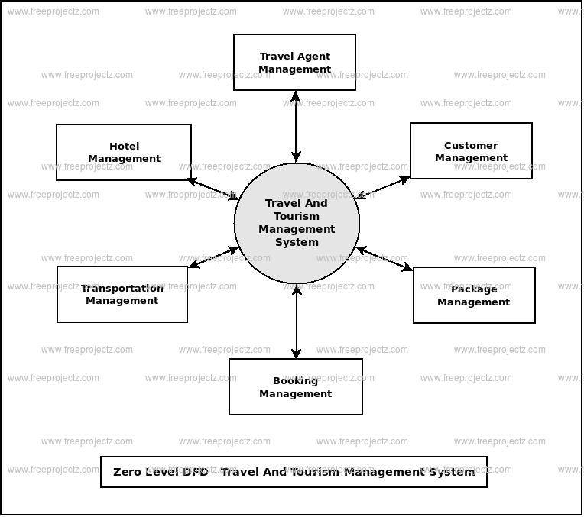

**TECHNIQUES**

“Frontend and Backend” are the two primary parts of web development, each with distinct roles in building a web application.

**Frontend**

The frontend is the user-facing part of a web application—the part that users directly interact with, also known as the "client-side." It involves the layout, design, and interactivity of the application. Key aspects are:

**Languages:**

1. **HTML (HyperText Markup Language)**: Defines the structure of the webpage.
2. **CSS (Cascading Style Sheets)**: Styles the HTML elements, controlling layout, colors, fonts, etc.
3. **JavaScript**: Adds interactivity, like form validation, animations, and responsive elements.

**Backend**

The backend is the server-side part of the application, responsible for handling data, business logic, and server-related operations.

**Languages :**

1. Common backend languages include Java, Python, PHP, Ruby, Node.js.
2. **Frameworks:** Backend frameworks streamline development. Examples include Django for Python, Express.js for Node.js, and Spring Boot for Java.
3. **Databases:** Databases store and manage application data, such as user profiles and content. Examples include MySQL, PostgreSQL, MongoDB, and SQLite.

**CODING:**

**Index.html**

<!DOCTYPE html>

<html lang="en">

<head>

<title>Travel Website - Sign Up</title>

<link rel="preconnect" href="https://fonts.gstatic.com">

<link href="https://fonts.googleapis.com/css2?family=Poppins:wght@300;400;500&display=swap" rel="stylesheet">

<style>

* {

margin: 0;

padding: 0;

box-sizing: border-box;

font-family: 'Poppins', Arial, sans-serif;

}

body {

display: flex;

justify-content: center;

align-items: center;

height: 100vh;

background-color: #f3f4f6;

background: url(v.jpg) no-repeat center center/cover;

}

.signup-container {

padding: 2rem;

border-radius: 12px;

width: 90%;

max-width: 400px;

text-align: center;

}

.signup-container h2 {

margin-bottom: 1.5rem;

font-size: 2rem;

color: black;

}

.signup-form .form-group {

margin-bottom: 1.5rem;

text-align: left;

}

.signup-form label {

display: block;

margin-bottom: 0.5rem;

font-weight: 500;

color:black;

}

.signup-form input {

width: 100%;

padding: 0.8rem;

border: 1px solid #ccc;

border-radius: 8px;

font-size: 1rem;

color: #333;

transition: border-color 0.3s, box-shadow 0.3s;

}

.signup-form input:focus {

border-color: #007bff;

outline: none;

box-shadow: 0 0 8px rgba(0, 123, 255, 0.3);

}

.btn {

width: 100%;

padding: 0.9rem;

background-color: #007bff;

border: none;

border-radius: 8px;

font-size: 1rem;

color: #fff;

cursor: pointer;

transition: background-color 0.3s;

}

.btn:hover {

background-color: #0056b3;

}

.signup-container p {

margin-top: 1rem;

font-size: 0.95rem;

color: #555;

}

.signup-container a {

color: #007bff;

text-decoration: none;

transition: color 0.3s;

}

.signup-container a:hover {

color: #0056b3;

text-decoration: underline;

}

</style>

</head>

<body>

<div class="signup-container">

<h2>Create an Account</h2>

<form action="su.php" method="POST" class="signup-form">

<div class="form-group">

<label for="name">Full Name</label>

<input type="text" id="name" name="name" required>

</div>

<div class="form-group">

<label for="username">Username</label>

<input type="text" id="username" name="username" required>

</div>

<div class="form-group">

<label for="password">Create Password</label>

<input type="password" id="password" name="password" required>

</div>

<div class="form-group">

<label for="confirm-password">Confirm Password</label>

<input type="password" id="confirm-password" name="confirm-password" required>

</div>

<button type="submit" class="btn">Sign Up</button>

</form>

<p style="color:black;">Already have an account? <a href="login.html">Login here</a></p>

</div>

</body>

</html>

**SU.PHP**

<?php

$name = filter_input(INPUT_POST, 'name');

$username = filter_input(INPUT_POST, 'username');

$password = filter_input(INPUT_POST, 'password');

$confirm_password = filter_input(INPUT_POST, 'confirm-password');

if (!empty($username)) {

if (!empty($password)) {

if (!empty($name)) {

if ($password === $confirm_password) {

$host = "localhost";

$dbusername = "root";

$dbpassword = "";

$dbname = "travel";

$conn = new mysqli($host, $dbusername, $dbpassword, $dbname);

if ($conn->connect_error) {

die("Connection failed: " . $conn->connect_error);

} else {

$hashed_password = password_hash($password, PASSWORD_DEFAULT);

$sql = "INSERT INTO users1 (name, username, password) VALUES ('$name', '$username', '$hashed_password')";

if ($conn->query($sql)) {

echo "New record inserted successfully";

} else {

echo "Error: " . $sql . "<br>" . $conn->error;

}

$conn->close();

}

} else {

echo "Passwords do not match";

}

} else {

echo "Name should not be empty";

}

} else {

echo "Password should not be empty";

}

} else {

echo "Username should not be empty";

die();

}

?>

**RESULTS**

**1.Home page:**

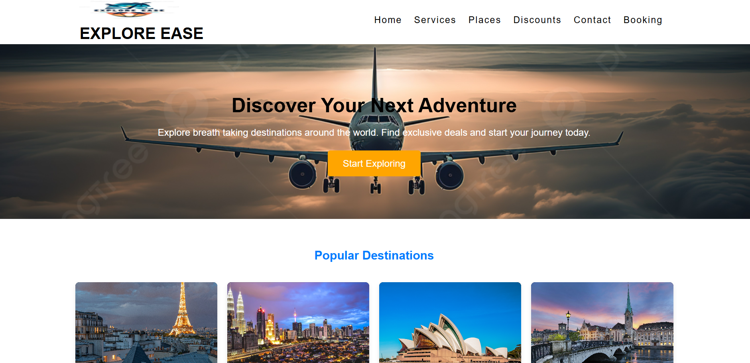

**2.signup page:**

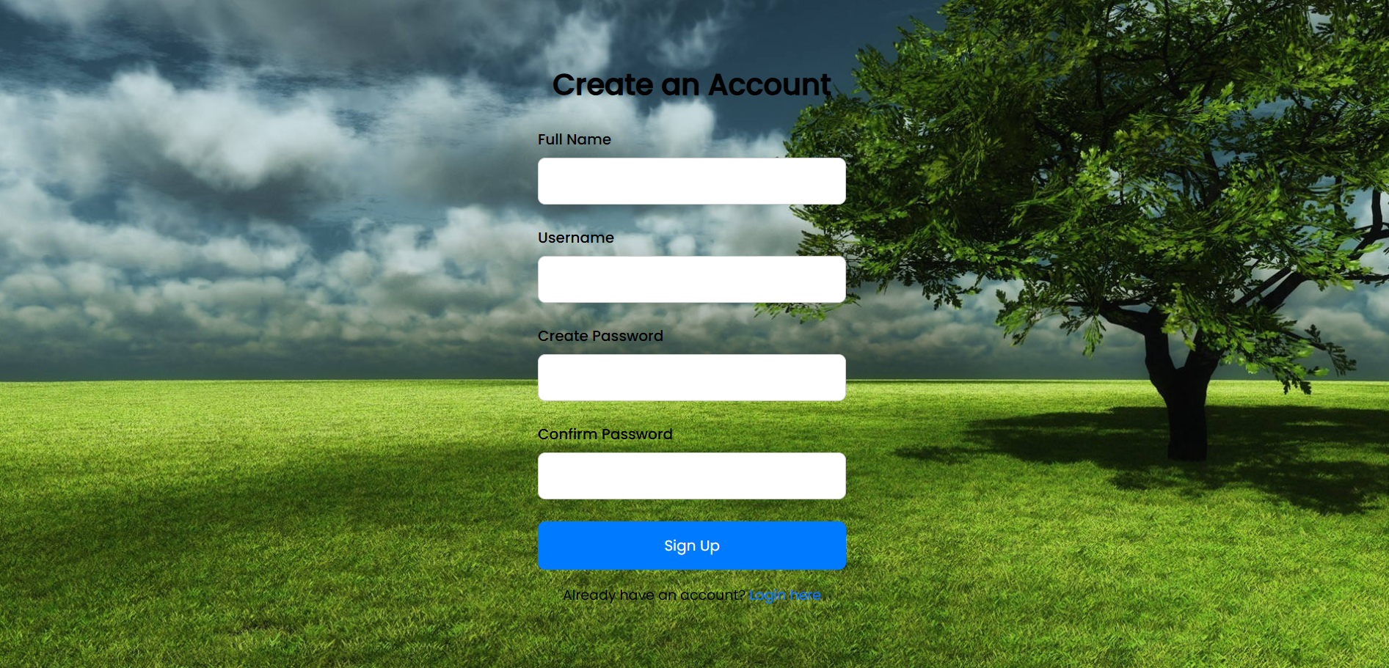

**3.login page:**

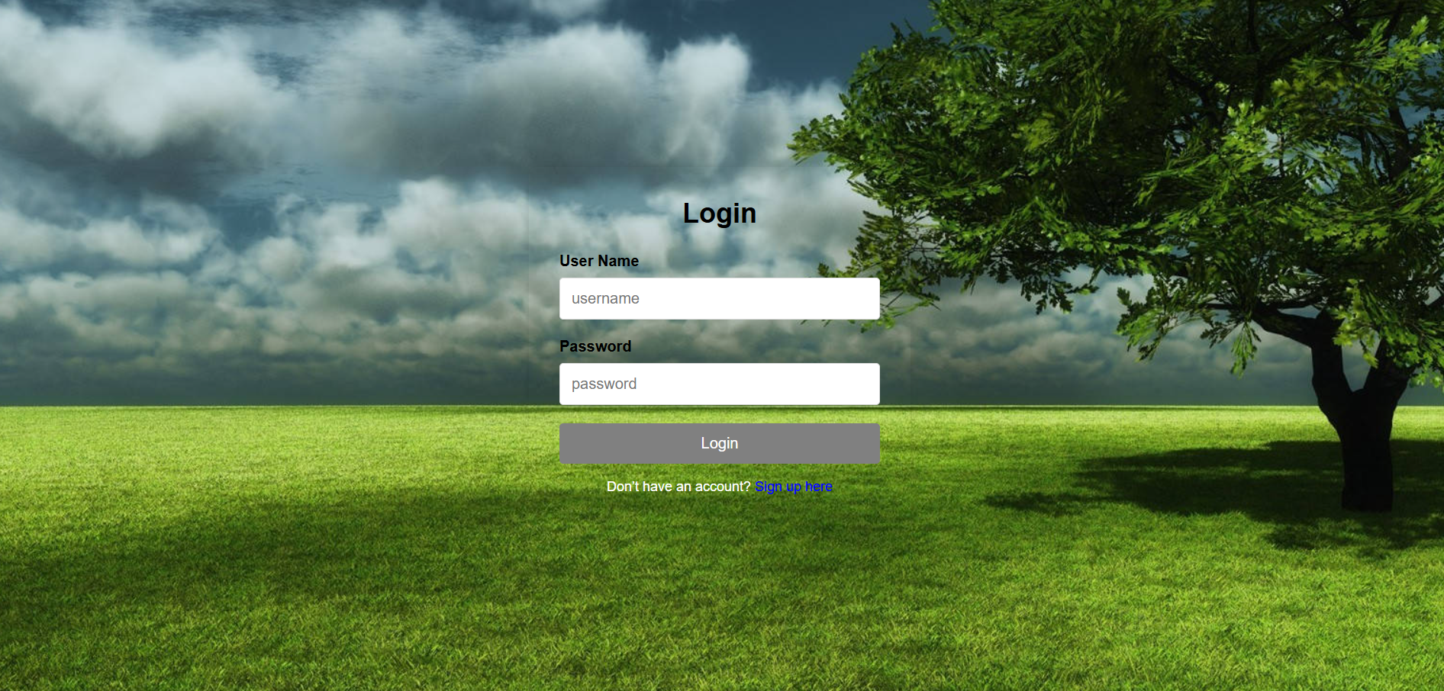

**4.Demo page:**

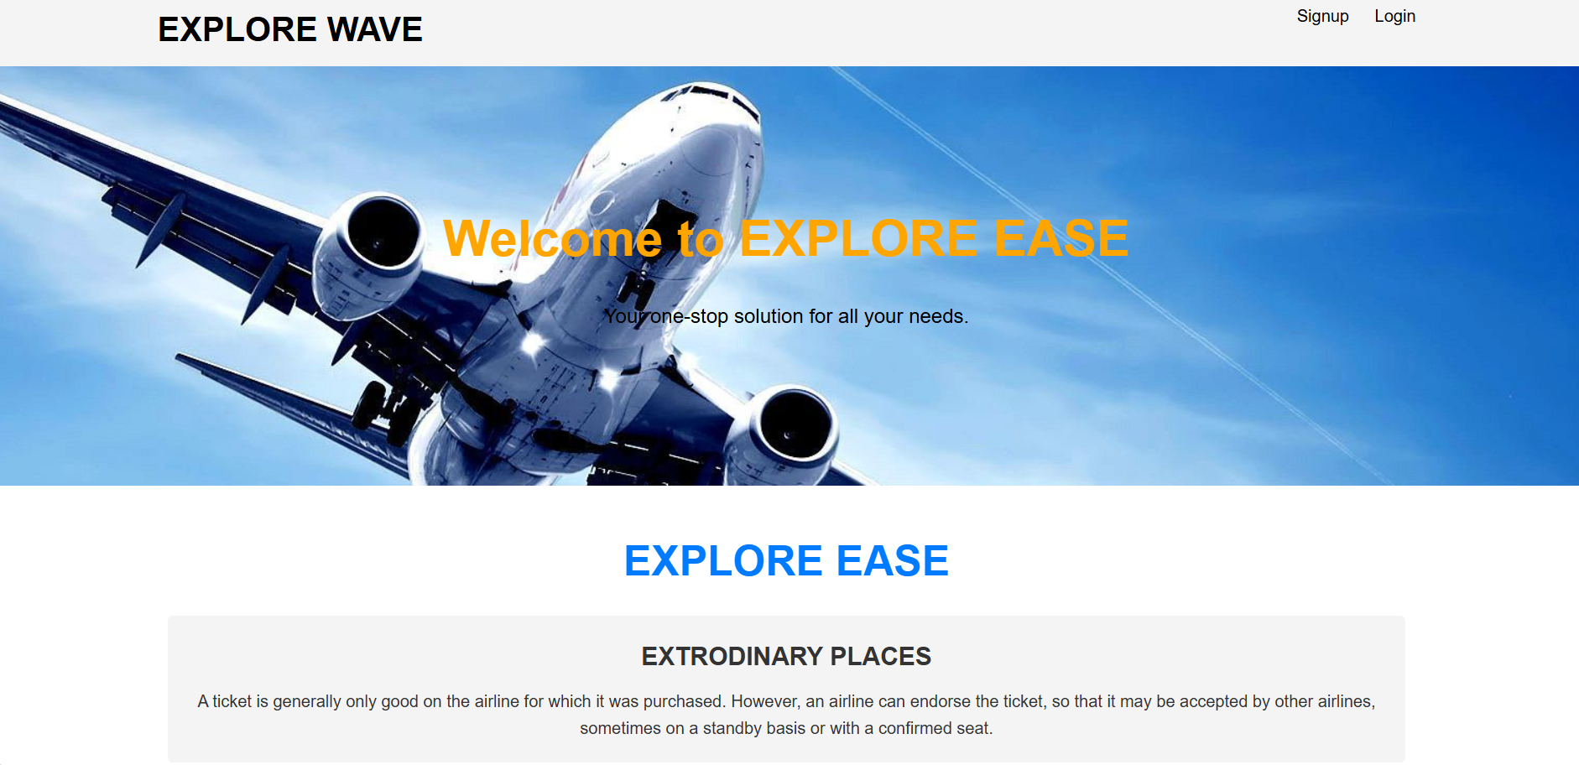

**5.Inserting data successfully:**

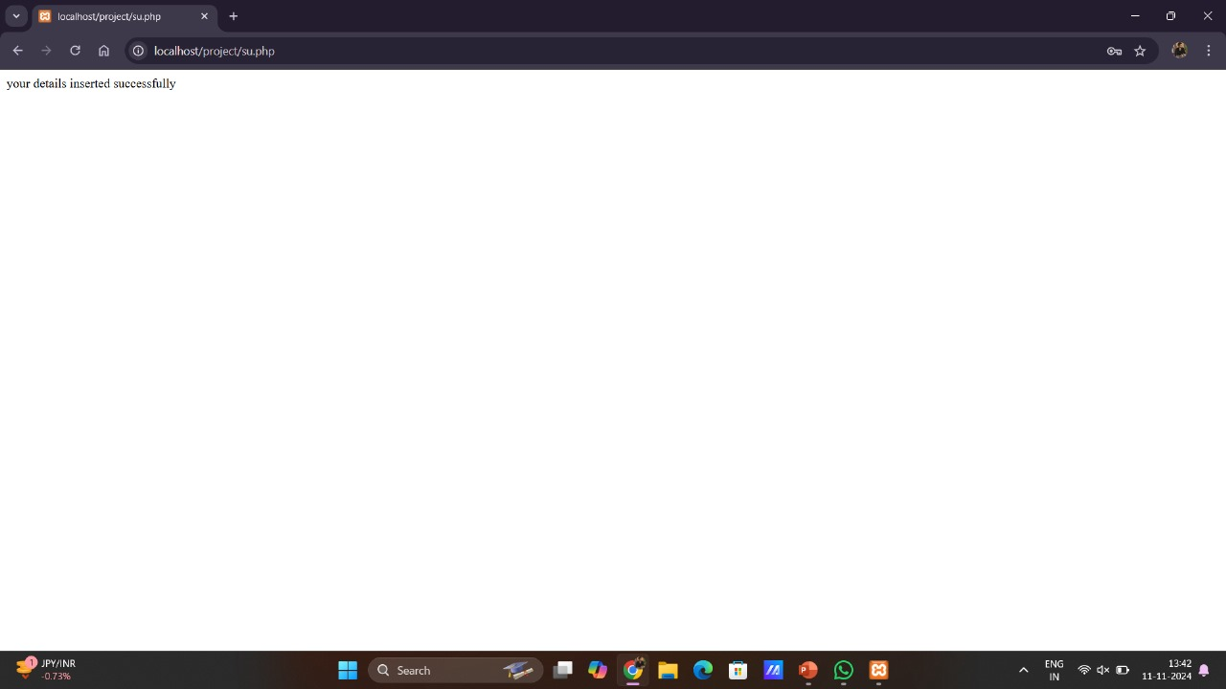

**6.Logged Successfully:**

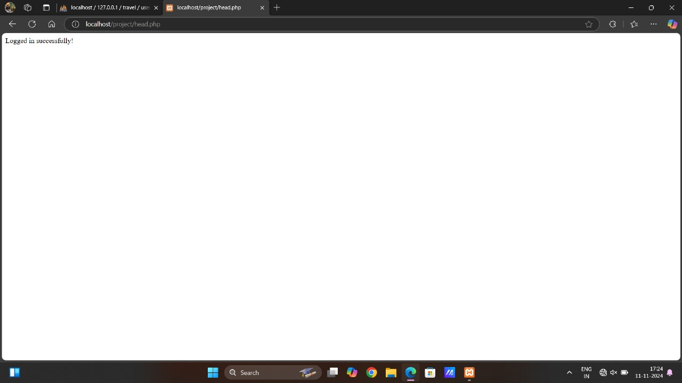

**CONCLUSION**

The travel booking system website provides a seamless and user-friendly platform for customers to book flights, hotels, and tours, ensuring a smooth travel experience. By integrating advanced features like real-time availability, secure payment processing, and personalized recommendations, the website aims to meet the diverse needs of travelers. The design focuses on simplicity and functionality, offering intuitive navigation that enhances user satisfaction. Overall, the platform is built to provide efficiency and convenience, positioning it as a trusted resource for both leisure and business travelers.

**Future Enhancement**

In the future, the travel booking system could be enhanced with AI-powered features like voice search, personalized travel itineraries, and predictive pricing algorithms to offer users better deals. Additionally, implementing a multi-language and multi-currency feature would cater to international users, expanding the website’s global reach. Integration with social media for easy sharing of travel experiences and user-generated content would further increase engagement. Lastly, incorporating augmented reality (AR) to preview destinations and accommodations could provide a more immersive and informed decision-making process for travelers.

**REFERENCES**

1. Shekar, Dhruti, Bhoomika V, and Dr. Manjunath S. 2024. “Revolutionizing Travel: An Introduction to a Voice-Enabled Flight Booking System Powered by Machine Learning.” *International Journal of Advanced Research in Science, Communication and Technology*, February, 465–69.
2. López-Perea, Noemí, Silvia Rivera Ariza, María Magdalena Salom Castell, Conchita Izquierdo Gómez, Montserrat Guillaumes, Aurora Fernández-García, Juan E. Echevarría, et al. 2024. “Coordinated Public Health Actions Following the Identification of a Measles Case Arriving on an International Flight, Spain: December 2022-January 2023.” Travel Medicine and Infectious Disease 62 (102768): 102768.
3. I Gede Agus Sukertha Yasa, and Ni Putu Evi Wijayanti. 2023. “The Influence of Brand Awareness and Brand Image on Customer Loyalty in Purchasing Domestic & International Flight Tickets: Case Study on Antavaya Bali.” Pusaka : Journal of Tourism, Hospitality, Travel and Business Event, August, 126–35.
4. Meyer, Jan Felix, Go¨ran Kauermann, and Michael Stanley Smith. 2024. “Interpretable Modelling of Retail Demand and Price Elasticity for Passenger Flights Using Booking Data.” Statistical Modelling 24 (1): 82–106.
5. Kortsch, Timo, and Phyllis Händeler. 2024. “Explaining Sustainable Purchase Behavior in Online Flight Booking—Combining Value-Belief-Norm Model and Theory of Planned Behavior.” Gruppe Interaktion Organisation Zeitschrift Für Angewandte Organisationspsychologie (GIO) 55 (2): 127–40.
6. Otsuka, Emiri, and Namgyu Kang. 2023. “Usability of Booking a Flight Ticket Using Airline Applications on Smartphones.” In Human-Centered Design and User Experience. AHFE International. https://doi.org/10.54941/ahfe1004245.
7. Rathore, Rajat, Taharat Nayeem, Kartik Sharma, Sahil Rathore, Satyam Tripathi, and Er Shikha Bharti. 2024. “Online Flight and Hotel Booking with Recommendation.” International Journal For Multidisciplinary Research 6 (2). https://doi.org/10.36948/ijfmr.2024.v06i02.18594.(Rathore et al. 2024)
8. Dai, Ruochen, Dongmei Guo, Yajie Han, and Yu Qin. 2024. “Pollution-Induced Trips: Evidence from Flight and Train Bookings in China.” Journal of Development Economics 171 (103340): 103340.